San Diego County Operational Area
Fireground Accountability Tracking Report

Captain = #1

Point of Entry: IDLH Accountability: Division / Group:
Engineer = #2 IC / OPSC:
1st Firefighter = #3 RESL:
2nd Firefighter = #4 Radio Channels:

ID # | # of Pers. | Location | Times | ID # | # of Pers. | Location | Times

STANDARD ACCOUNTABILITY TAG (Samples)
All 2” x 1 1/8” Dog Tags no notch are all Anodized Aluminum Laser Engraved on both sides

TYPE 1 & TYPE 3 Engines - Red Tag with Agency Name, Resource Type, Resource Number and Rank / Position Number
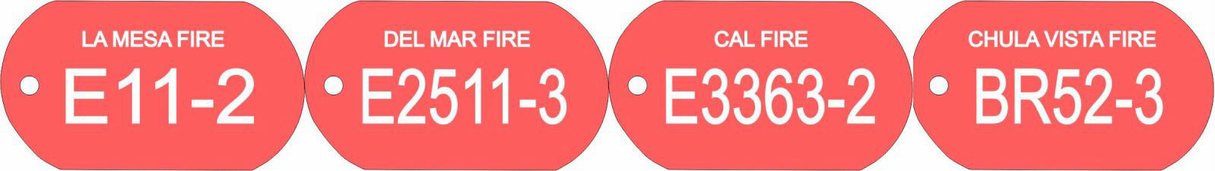
Trucks - Black Tag with Agency Name, Resource Type, Resource Number and Rank / Position Number
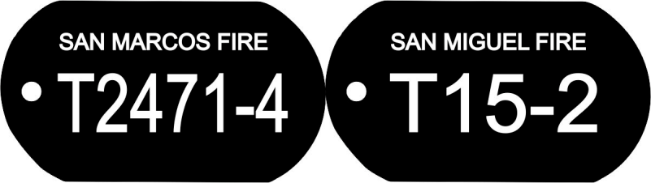

Medic or BLS Rig - Blue Tag with Agency Name, Resource Type, Resource Number and Rank / Position Number
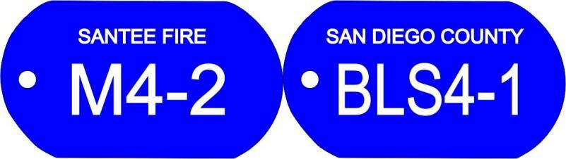
Chief Officers and Other Staff - Purple Tag with Agency Name, Resource Type, Resource Number

FC - Fire Chief
AC - Assistant Chief
DIV - Division Chief
DEP - Deputy Chief
TRN - Training Staff
SFTY - Safety Staff
B - Battalion Chief

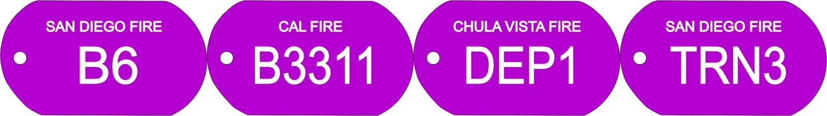

Specialty Rig & Resources - Green Tag with Agency Name, Resource Type, Resource Number and Rank / Position Number if Applicable

HM - Haz Mat Rigs
R - Recue Rigs
LA - Light & Air Rigs
INV - Arson Investigators
CPTR - Helicopters
XR - Bomb Units

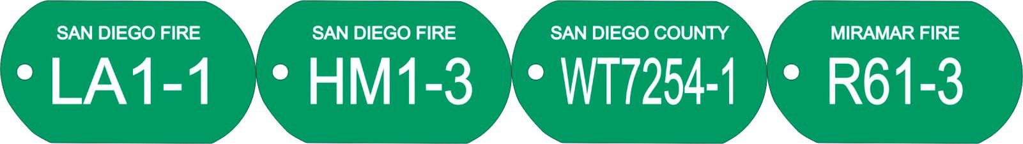

STANDARD COMPANY TAG Samples & ASSOCIATED EQUIPMENT

1 1/8” HEXAGON SHAPED Anodized Aluminum Laser Engraved on both sides
Color coded with Agency Name, Resource Type, Resource Number

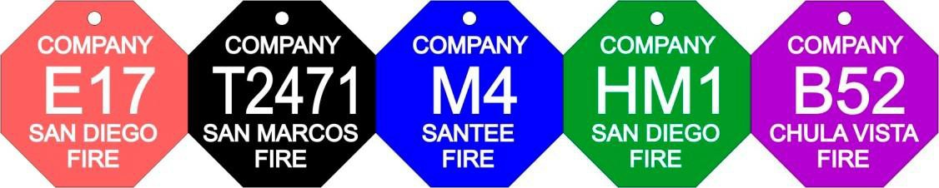

Saunders RR8514 Clipboard Box with
3/16” Orange Acrylic Cover assembled with Agency vinly designator sticker inside and outside of box
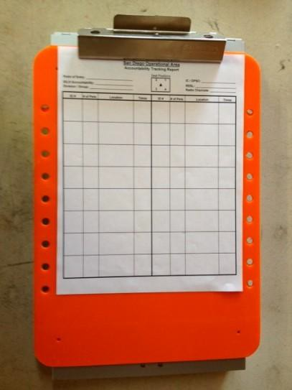

Campbell/Cooper ½” nickel-plate
Trigger Snap with ½” split key ring,
and 2” x 1 1/8” red dog tag assembled.
Each piece sold seperately.

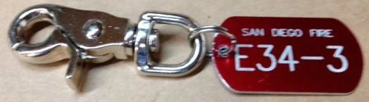
Parts are unassembled. A complete assembly, requires a Trigger Snap, ½” split key ring, and color coded tag needed
Replacement 3/16” Orange Acrylic Cover with holes, assembly ready, no drilling.

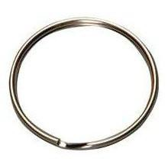
2” HY-KO Products nickel-plated split key ring needed for attachment point for Trigger Snap for some SCBA’S brands/models

½” nickel plated split key ring needed to attach tags to Trigger Snap

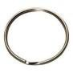

Solarplacard Inc. Order Form for Fireground Accountability Products
1485 Country Vistas Lane, Bonita, CA 91902
619-507-7538 Off. 619-507-7079 CELL E-Mail - sales@solarplacard.com
Please fill out form clearly and provide contact information including email and phone.
Name of Person Ordering:
Phone Number:
Agency Designator: (ie. Oceanside Fire, Cal Fire)
Accountability Tags (AT) @ $3.25 each
Tag Type: | Color: | Resource  Type: | Unit #: | Rank / Position #: | Total # of SCBA Harnesses on Rig | Total # of  Tags Per:
AT | Red | E | 51 | 1, 2, 3 | 3 | 3
AT | Red | BR | 3363 | 1, 2, 3 | 3 | 3
AT | Black | T | 12 | 1, 2, 3, 4 | 4 | 4
Company Tags (CT) @ $3.250ach
Tag Type: | Color: | Resource  Type: | Unit #: | Total # of Tags Per: | Clipboard  Designators:
CT | Red | E | 51 | 1 | Engine 51
CT | Black | T | 12 | 1 | Truck 12
CT | Purple | B | 3 | 1 | Batt 51
Accessory Equipment
Qty: | Price: | Item:
 | $90.00 | Complete Clipboard with Suanders Box with 3/16" Orange Acrylic Cover, assembled with designation vinyl sticker inside and out
 | $3.25 | 1/2" Nickel Plated Trigger Snap - Campbell/Cooper #T7616412
 | $0.20 | 1/2" Split Key Ring - Nickel Plated
 | $4.00 | 2" Split Key Ring - Nickel Plated
 | $30.00 | Replacement Orange Acrylic Cover with holes for mounting, ready to assemble
 |  | ** Attach additional order forms as necessary |  |  |  | Updated 10/1/23

